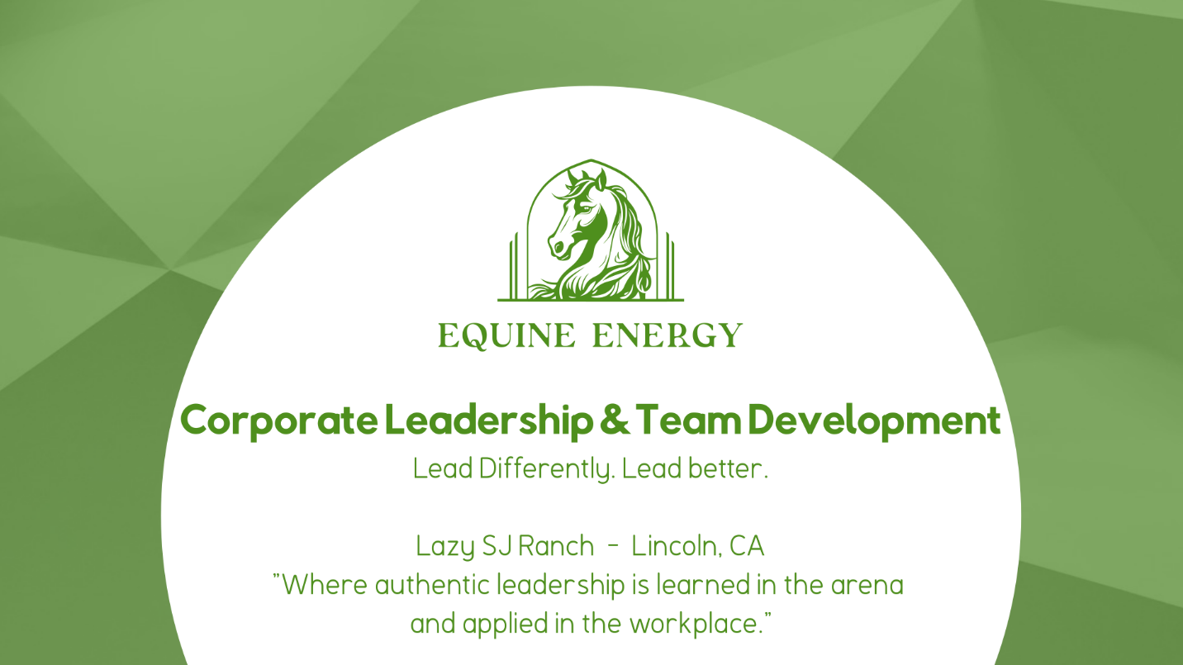
WHY THIS WORKS

The Problem with Traditional Leadership Training
Leadership development is a multi-billion-dollar industry — and most of it isn't working. Research consistently shows that only 10–15% of skills learned in classroom or lecture-based training actually transfer to on-the-job behavior. Teams return from workshops energized, only to slip back into the same communication patterns, trust gaps, and leadership blind spots within weeks.
Today's organizations are navigating compounding complexity: hybrid work, post-restructuring friction, disengaged employees, and leaders who are technically skilled but struggling to build the psychological safety their teams need. Conventional training addresses the intellect. It rarely touches behavior.
Equine-Assisted Learning (EAL) is different — and the difference is measurable. Horses respond only to authentic leadership presence. They cannot be fooled by a confident tone, a polished slide deck, or a senior title. They react in real time to incongruence, hesitation, and unspoken tension — giving participants honest, non-judgmental feedback that no 360 survey can replicate. The result: accelerated self-awareness, rapid team calibration, and behavioral insight that sticks.

"The most powerful leadership feedback I have witnessed in 20 years of organizational development — delivered without a single word from the horse."

PROGRAM OFFERINGS

Our Programs
Three powerful pathways to stronger leadership, deeper trust, and more effective teams — all grounded in experiential learning with horses. Programs are held at our ranch in Lincoln, CA. No riding. No horse experience required. Additional package programs are also available on a monthly and/or quarterly basis.

Leadership Essentials Workshop
Build stronger, more emotionally intelligent leaders through experiential learning with horses.
This 2-hour workshop helps managers and emerging leaders strengthen communication, emotional intelligence, and presence. Horses respond instantly to clarity, intention, and authenticity — giving participants real-time feedback they can apply immediately in the workplace. No riding and no horse experience required.

Includes
- Core leadership or communication activity with horses
- Facilitated debrief
- Light refreshments
- Post-session summary (1–2 insights)
Best for: Small teams, leadership groups, new managers

Team Dynamics & Trust-Building Workshop
Strengthen communication, trust, and collaboration in a powerful experiential session.
Designed for teams navigating stress, change, or communication challenges, this workshop reveals team patterns and strengthens cohesion through hands-on activities with horses. Participants learn how their communication impacts results and leave with actionable insights to bring back to the workplace.

Includes
- Two experiential obstacle activities with horses
- Full team debrief
- Leadership insights tied to workplace behaviors
- Light refreshments
- Post-session action recommendations
Best for: Mid-sized teams, offsites, team resets

Leadership Intensive Half-Day Retreat
A deep-dive leadership and team development experience for executive or high-impact teams.
This retreat blends experiential leadership modules, communication work, and emotional intelligence development. Teams gain clarity, strengthen trust, and uncover blind spots that impact performance. Includes a post-retreat insights report to support ongoing growth.
Includes
- Three experiential leadership challenges with horses
- Deep-dive communication + emotional intelligence work
- Personalized leadership insights
- Team culture mapping
- Refreshments
Best for: Executive teams, leadership cohorts, culture resets

HOW IT WORKS

A Typical Session: The Arc of the Day
Every session is expertly paced to alternate between experience and reflection — the proven cycle for lasting behavioral change. Below is the flow for a typical Team Dynamics Workshop. Each of our programs follow an adapted version of this structure.

# | Phase | Duration | What Happens
1 | Welcome & Safety Briefing | 10 min | Introductions, ground rules, equine safety orientation — setting the stage for trust and full engagement
2 | Grounding & Intention Setting | 15 min | Participants articulate personal and team intentions; facilitator frames the learning arc for the day
3 | Equine-Assisted Exercises — Round 1 | 45 min | First structured challenge with horses — focused on communication, presence, and real-time leadership observation
4 | Facilitated Debrief & Insight Extraction | 20 min | Structured conversation connecting equine observations to team and leadership behavior; naming patterns
5 | Equine-Assisted Exercises — Round 2 | 45 min | Second challenge with increased complexity — participants apply Round 1 insights; deeper individual leadership moments
6 | Team Reflection & Application Planning | 20 min | Teams co-create specific behavioral commitments; individuals name their one leadership edge to work on

"Horses live entirely in the present moment. They are the ultimate mirror for leadership authenticity — and they give feedback that no human coach can replicate without flinching."

INVESTMENT

Program Pricing
Our programs are priced to reflect the depth of preparation, facilitation expertise, and post-session integration support included in every engagement. All pricing is per-program, not per-person — making the investment scalable for your team size.

Program | Format | Investment
Corporate Essentials Workshop | Up to 8 participants | 2 hours | $650
Team Dynamics & Trust-Building Workshop | Up to 10 participants | 2.5 hours | $1,200
Leadership Intensive Half-Day Retreat | Up to 12 participants | 4 hours | $2,400

Custom Engagements Available. Custom pricing is available for groups over 12 participants, multi-team engagements, and organizations seeking a monthly or quarterly program. Contact us to discuss a tailored proposal.

CLIENT VOICES

What Leaders Are Saying

"We were seeking an innovative L&D training program to recharge our team. The concept of equine assisted workshops was new to us and we were skeptical. We left our session with a framework for how our team actually communicates — and why it had been breaking down for months. This wasn't a ropes course. It wasn't a personality assessment. It was real. The debrief alone was worth the investment."

"I have led teams for fifteen years. I have done the executive coaching, the 360 reviews, the leadership intensives. None of it prepared me for standing in an arena with a 1,200-pound horse that did not care about my title, my resume, or my projected confidence. That was the most honest feedback I have ever received as a leader — and I needed every bit of it."
— Senior Director of Operations, Sacramento Region

"Our team was struggling with cohesiveness and group dynamics. It was truly holding us back from achieving our potential. The Half Day Retreat was exactly what we needed to change our dynamics and performance in the office. To this day, while strategizing our goals, we reflect back on what we learned that day and it gives us positive direction. I will be sending teams to this experience several times each year without hesitation.”
— HR Business Partner, Regional Healthcare Organization, Northern California

“When booking our visit to Equine Energy, some members of our group were unsure of interacting and learning from horses. Some even had a fear of being near them. Sherry made everyone feel at ease and everyone willingly participated. And enjoyed it! It became clear no experience is necessary. The insights gained were invaluable. We will be back for a half day retreat…. Maybe several!”
— Commercial Real Estate Mgmt Group, Chico, CA

YOUR FACILITATOR

About Sherry

Sherry Jacobson Certified Equine-Assisted Learning Facilitator | Lincoln, CA

Sherry Jacobson is a certified equine-assisted learning facilitator and organizational development practitioner based on her ranch in Lincoln, CA. With a foundation in both human behavior and horsemanship, Sherry brings a rare dual expertise to the corporate leadership space — the ability to read individual and group dynamics in real time, and to design experiential challenges that surface exactly what a team needs to see about itself.

Sherry has spent her entire life around horses and is trained in several riding disciplines. The Lazy SJ Ranch where she resides has a variety of horses, miniature horses, a sweet donkey, chickens, pot-bellied pigs and more – many of which are a part of her programs. After working 40 years in the business world, Sherry recognized that the leadership skills organizations needed most — presence, emotional regulation, authentic influence — could not be taught in a classroom. She founded Equine Energy to bridge that gap. She became certified in Equine Assisted Psychotherapy (EAP) and Equine Assisted Learning (EAL), and developed programs that produce results. Every program Sherry facilitates is grounded in evidence-based practice, safety-first equine protocols, and a deep respect for both the horses and the humans in the arena.
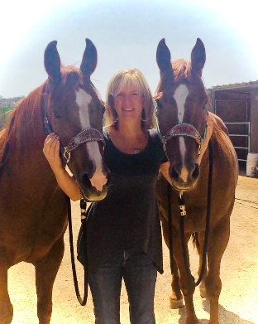

Our Horses. Our program horses are carefully selected, trained, and cared for by Sherry on our Lincoln, CA ranch. Each horse is chosen for temperament, sensitivity, and their ability to serve as authentic partners in the learning process. Horse welfare is central to everything we do — sessions are paced, structured, and designed with the well-being of both horses and participants as the highest priority.

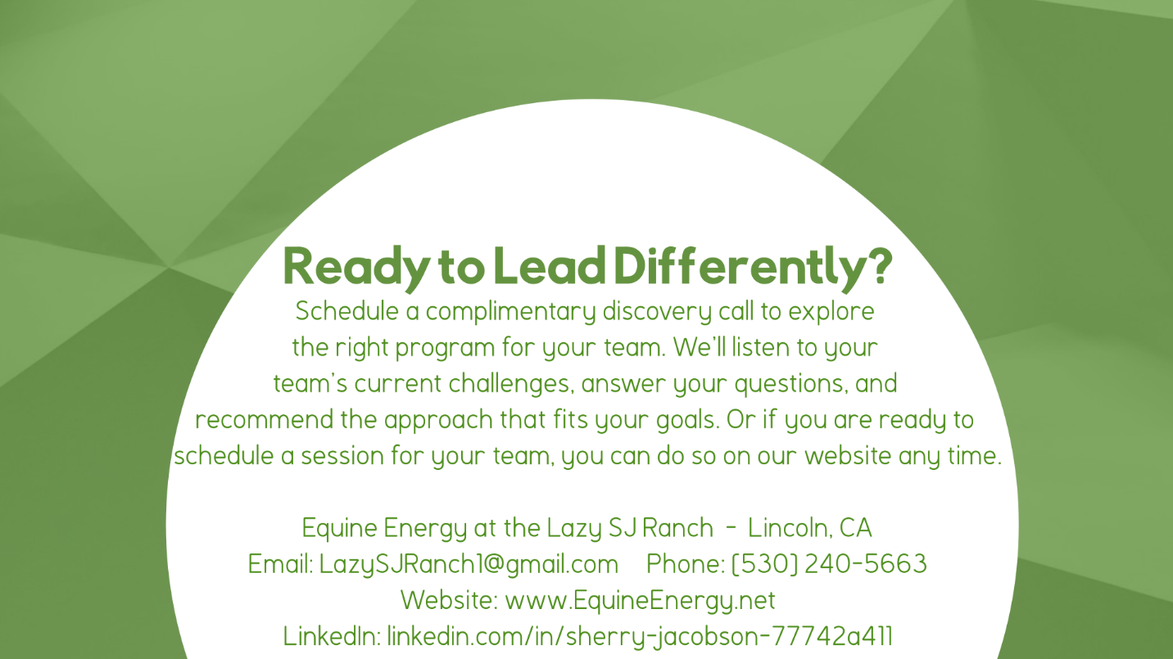



© 2026 Sherry Jacobson]0. All rights reserved. Programs facilitated in accordance with equine safety and professional ethics standards.

